978-1-5090-5256-1/16/$31.00 c 2016 IEEE

TCP/IP Remote Communication for Arduino based Motion Control using Virtual Instrumentation

Shital Patil1, Dr. D. V. Padole2 Student1, Professor2

Department of Computer Science & Engineering1, Department of Electronics Engineering2

G. H. Raisoni College of Engineering, Nagpur, India

# Abstract:

Describing with several methods to achieve of remote data acquisition based on LabVIEW, introduced the design method in the LabVIEW platform, combined with Aurduino and TCP / IP protocol for data acquisition and transmission of the long-range ,and realization of the signal on the time-domain analysis and on the frequency-domain Analysis. Two computers running LabVIEW at the same time, real-time data send and receive between computers by the interface of Virtual Instrument, which can realize multi-machine data transmission and reading, in order to complete remote data sharing and controlling. LabVIEW platform provides a support for remote controlling and the monitoring of equipment. Proposed system is aimed at design and development of remote laboratory activities monitoring and controlling system for motion control using h-infinity algorithm.

**Keywords:** TCP/IP; h-infinity; Motion Control

# INTRODUCTION

Virtual experiment about teaching environment research has become a new hot spot in the current education research. Virtual experiment platform reduce the cost of laboratory construction. It mainly relies on software and less behind hardware. Preservation costs and the laboratory work were also greatly reduced. Network experimental platform of virtual instrumentation can be design a variety of virtual instruments according to the experiments require of various course. It can replace traditional instruments to achieve the laboratory network, as well as it can decrease the cost of laboratory apparatus, pick up the experimental teaching conditions and achieve resource sharing. United States National Instruments (NI) Company firstly proposed the virtual instrument (Virtual Instruments referred to VI). The LabVIEW which represents the graphical development atmosphere is not only powerful, but also can efficiently decrease the cost of progress applications. With the development of network technology and their applications, Acquiring network applications, which is on totally based on the virtual instrument (VI) technology based on the LabVIEW is an exploration focus in the current interior. International virtual instrument Overview

In this paper hardware devices uses Aurduino Board and interface board. The LabVIEW stage realize data achievement. For the purpose of motion organize testing, and a reference PID controller and application of several H- infinity (H∞) advanced control algorithms {namely S/KS understanding, 1DOF and 2DOF Glover-McFarlane loop- shaping procedures} were symphonized and implement. From theory (particularly for motion control positioning application) it can be seen that the peak magnitudes of the sensitivity functions can be associated with the H∞ norm and the emanate outcomes from these relations. Based on this, the S/KS H*∞* mixed sensitivity design was selected [3, 4]. Further, the normalized co major factor plays an important role in the robust stabilization. The Glover-

McFarlane loop-shaping procedure [5] was chosen, together with the choice of the pre-compensator and post compensator weights of the augmented plant. That leads to the H***∞*** optimal problem formulation, the maximization of the constancy and the one-step synthesis of the H***∞*** controller. The two-degrees-of-freedom design comes as a natural continuation of the Glover-McFarlane loop-shaping procedure since it shows better outcomes when the reference signal is treated unconnectedly from the measured feedback signal.

The basic goal towards the work is to design a communication interface based on LabVIEW for motion control of component. The complete serial communication driver design and implementation and also achieve two ways about network data transmission through TCP / IP. The technique is effectively used to achieve information to remotely control and access to local in sequence possession and demonstration. Data achievement and serial communication organically combined. Through online testing it will be verify function. Implementation of data acquisition was based on LabVIEW communication system with the real-time communication and easy maintenance for server and client.

The main objective of the work is used of LabVIEW software development platform, shared with data acquisition cards like Arduino and TCP / IP communication protocol to accomplish a long-range data gather and completed a time and frequency domain analysis. It compared with the straight data acquisition and processing system, it has the advantages of a cost-effective, high uniqueness, easy-to-improvement, data processing easy, short development time, the use of high-quality results. This can be make the users who do not have much experience free out as of the heavy programmers , make the users advance more effort in the pilot testing, data analysis and

processing, performance testing, greatly reducing development time.

# METHODOLOGY

1. **The easiest way Remote Desktop**

The easiest way of remote monitoring and control is to use Remote Desktop of Windows System instead of specific agreement in particular application. In a way, The server- side is to be Windows XP, and the client may use Windows 2000, Windows 98 and Windows XP. Remote Desktop constitutes server-side and client and can control one another system ought.

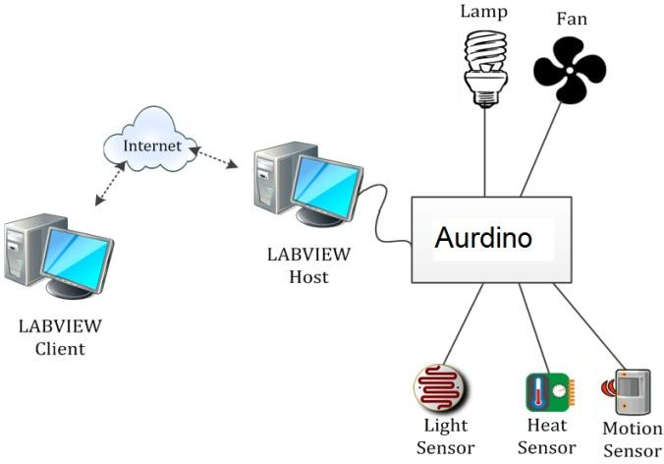

# Fig. 1 Internet Control of a Remote Laboratory

1. **The system hardware components**

The system has two computers, one server and other one is the client. The server computer collects data, store it for transmission later on and remotely control device parameters in real time; the client desktop receive data , process it and display. The system also use data transmission equipment, data acquisition cards and sensors such as bus. Hence, this system comprises of sensors, signal conditioning board, USB serial bus, on-site data collection computer, and transmission networks and remote data processing and analysis computer.

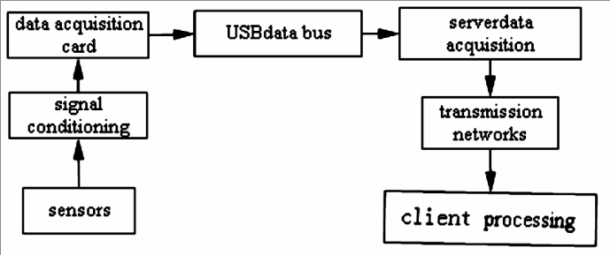

# Figure 2 The system hardware components

1. **To communicate use of the network protocol**

TCP / IP protocol is primary and reliable Internet protocol to control the flow of information using internet. LabVIEW supports TCP / IP protocol to achieve data communications. There are two sub-template given for TCP / IP protocol communications function, one is the TCP template for functions based on the TCP protocol communications. The other one for functions based on UDP protocol communications called as UDP template. In this way LabVIEW uses communication for remote data collection between the client and server.

# TCP transmission LabVIEW software

LabVIEW can achieve TCP communications by using published TCP module; it can design server / client mode of communication. virtual Instrument programmed has two parts: Client model dealing with the its main acceptance of data completion, its analysis along with data time and frequency domains analysis; Server model working for data acquisition, achieved Data collection and transmission. In server, request of the client received by TCP Create Listen. After TCP connection, TCP Write function nodes send data which in turn get transferred (strain, displacement, vibration, etc.) to the network. Then data get segregated int different types using Type Cast node function before sending to network. Reliazation of procedure was shown in Figure 3.

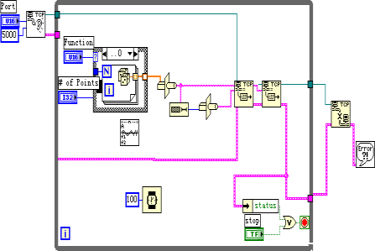

# Figure 3 . TCP / IP send procedure

In client, firstly, used TCP Open Connection node function to open a TCP connection which the remote port the server were designated. TCP Read node function receive the data transmitted by the server and then tested and processes it. Port must be same during sending and receiving process. Process diagram was in Figure 4.

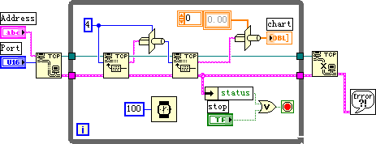

# Figure 4. TCP / IP receive procedure

1. **TCP / IP Network Communication Based On Labview**

To establish two communication networks between nodes we must establish communication interface between them, including both hardware and software parts. The software part implement a communication protocol. The interface hardware part achieve physical connection and information transfer between nodes. In the TCP / IP protocol, the port is a structure, constitutes abstract data structures and buffers. Port function is same as to file I / O operations, the port can both be read or written . In order to solve Different types of communications between the host process, we require a rival process of the network environment which can determine the port number and IP address.

# Server / Client based on LabVIEW

Web applications preferably use Client / server model. In client / server model, a set of clients request for service to

server. The functions which VI Client performs are enlisted below:

1. Client program creates a connection with a server program;
2. Send orders to the server;
3. collect a response;
4. Close the connection.

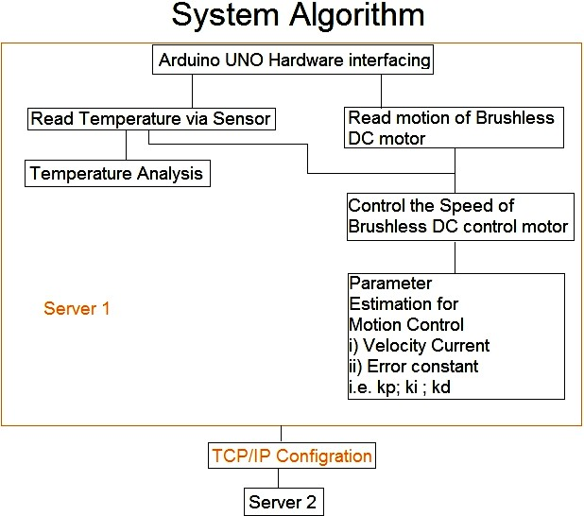

# Figure 4. Interfaces model

1. **DESIGN AND IMPLEMENTATION**

This narrative work based on the motion control parameter

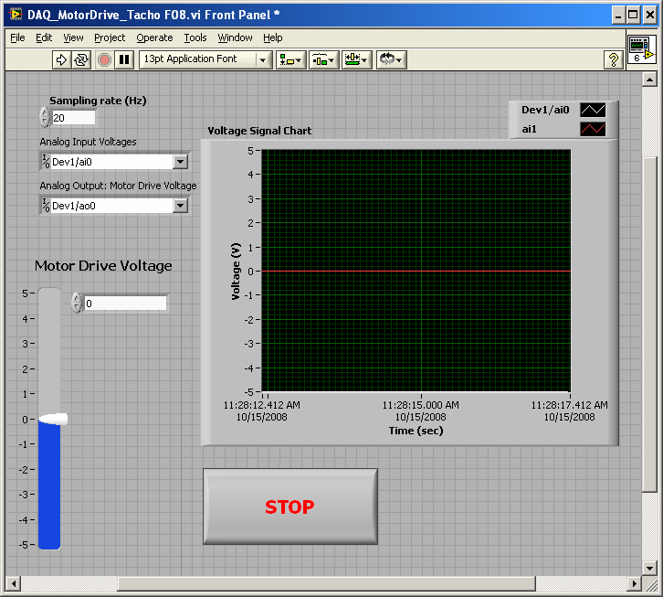

# Fig. 5. Motor drive control

1. **Control of DC Motor Velocity**

In this experiment, we will use a LabVIEW VI and an integral feedback control circuit to control a DC motor as shown in Figures 5.1 . Mathematically, the integral (I) controller can be described in the time domain as

*v*(t)  Ki *e*(n) dn

Where v(t) is the output and *K* is a constant gain

*I*

Where e(n) is the function of temperature.

1. *Proportional-Integral (PI) Control of DC Motor Velocity*

In this experiment, we use a LabVIEW VI and a proportional-integral (PI) feedback control circuit to control a DC motor. Mathematically, the PI controller can be described in the time domain as

*vPI* (t)  *Kp* e(t)  Ki *e*(n) dn

of Brushless DC motor as a controlling factor of temperature. The basic aim towards the implementation is h- infinity algorithm. Based on the control system the Change

Where *K*

*P*

and *K* are constant gains.

*I*

in temperature speed indicated the speed of DC Motor for motion control. In this laboratory, you will be write a LabVIEW program that will be permit you to drive on DC Motor by an analog voltage signal. You will be also learn how we can measure and view both angular velocity and angular position response signals from the motor. The DC Motor is a part of the MS15 DC Motor Controlling Module. The angular speed velocity of the motor can be controlled over using either an analog voltage signal pulse width modulated (P. W. M.) digital signal. In this laboratory, we will be use only analog signals.

In this remote laboratory, we will continue the investigating closed-loop feedback control of a DC motor. Your final goal is to control the DC motor such that the velocity (voltage)

# H-Infinity Algorithm

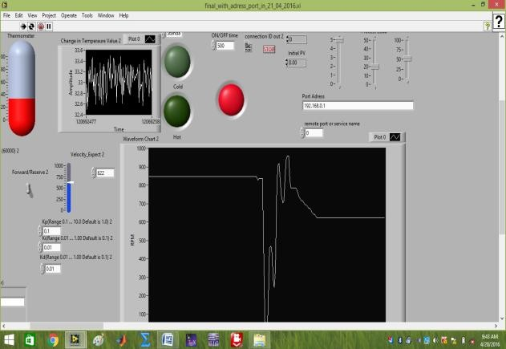H-infinity (H∞) – modern control methods in the H∞ space of matrix valued functions for mathematical optimization and controller synthesis, which achieve guaranteed robust performance or stability.

output **V**

**OUT**

is an equal to a (desired) reference (voltage)

input **r.**

In Lab 6a, you build analog proportional (P) and integral (I) control circuits. We will be combine these circuits into a proportional-integral (P-I) control circuit.

Fig. 6 LabVIEW Front Panel for Motion Control

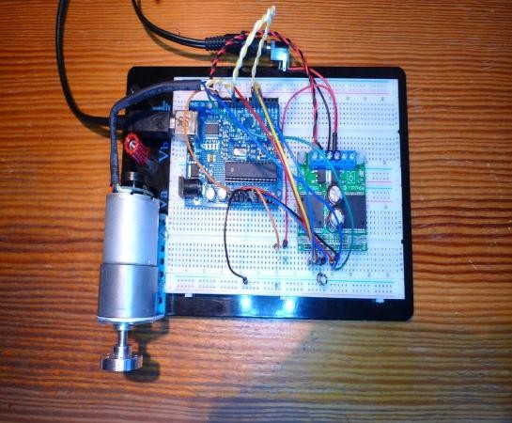

**Fig.6.3Experimental setup**

1. **CONCLUSION**

For remote connection of the web-client (representing the remote user) and motion control of the experimental workbench are proven feasible to be realized – LabVIEW Web Services and Remote Front Panels. The use of LabVIEW software development platform, joint with data acquisition and TCP / IP communication to attain a long- range data collection, and finished a time-domain signal study and frequency domain investigation. Compared with the established data acquisition and processing system, it has the reward of a lucrative, high universality, easy-to- development, data dispensation simple, little development time, and the use of good outcome.

# REFERENCES

[1]S.D. Gadzhanov, A. Nafalski ,” LabVIEW Based Remote Laboratory for Advanced Motion Control”.2014 IEEE, 11th International Conference on Remote Engineering and Virtual Instrumentation.

1. S. Gadzhanov, A. Nafalski, and Z. Nedic, "A FPGA Approach in aMotorised Linear Stage Remote Controlled Experiment,"International Journal of Online Engineering (iJOE), vol. 9, pp.55-63, April 2013.
2. Z. Nedic, "A UniversalWorkbench for Motion Control Experimentations in LabVIEWEnvironment," in 9th International Conference on RemoteEngineering and Virtual Instrumentation (REV), Bilbao, Spain,2012, pp. 51-57.
3. S. Gadzhanov, A. Nafalski, and O Gol, "A Remote Laboratory for Motion Control and Feedback Devices," Electrotechnical Institute Warsaw, Poland, pp. 37-50, 24-27 Jun 2010.
4. Karel Jezernik, Andreja Rojko, Darko Hercog

,“Experimentally Oriented Remote Motion Control Course for Mechatronic Students.”2008 IEEE.

1. S. Skogestad and I. Postlethwaite, Multivariable Feedback Control: Analysis and Design. New York: Wiley, 1996.

[7]D. Hoyle, R. Hyde, and D. Limebeer, "An H∞ Approach to Two Degree of Freedom Design," in 30th IEEE Conference on Decision and Control, 1991, pp. 1581-1585 vol.2.

1. Zorica Nedic, Jan Machotka, and Andrew Nafalski, Remote Laboratory NetLab for Effective Interaction with Real Equipment over theInternet”.2008 IEEE.
2. Michael Straatsma Christoph Ctistis, Rainer Bartz, “Development and Enhancement of RLab”. 2009 Fourth International Conference on Systems and Networks Communications.
3. Bingsheng Wu; Chaozhi Cai. Remote Data Acquisition and Signal Processing System Based on LabVIEW. From International Conference on Measuring Technology and Mechatronic Automation. 978-0-7695-3583-8. Pp (308-312) 2009.
4. National Instruments, “LabVIEW Graphical Programming”, 2013.
5. National Instruments, “LabVIEW Course LV1 & LV2”, 2013.
6. [www.ni.com/control](http://www.ni.com/control) toolkit, 2013.